|  |  |  |  |
| --- | --- | --- | --- |
|  |  | Merrimack River Watershed CSO Management  Jason Curtis / PPUA 5263 / 8.7.2024 |  |
|  |  |  |  |

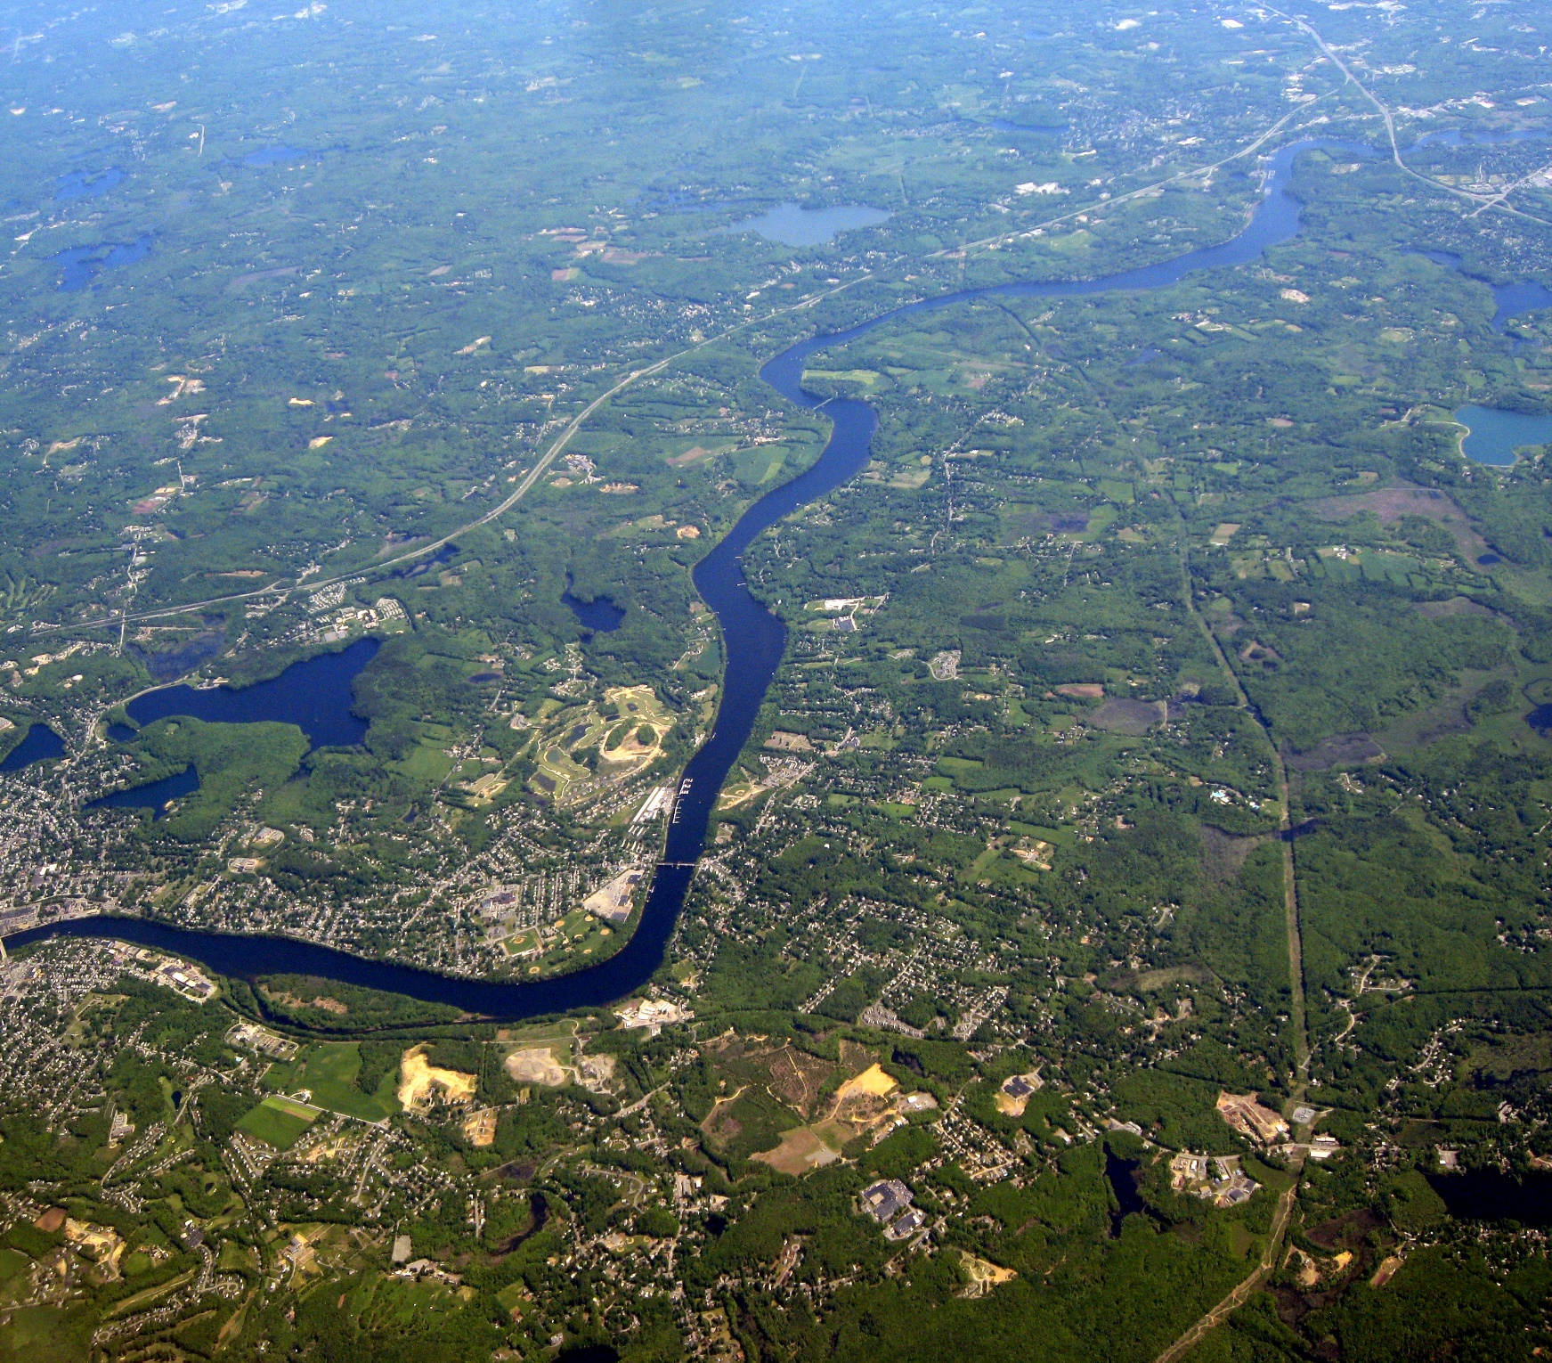

|  |  |  |  |
| --- | --- | --- | --- |
|  |  |  | |
|  |  | TABLE OF CONTENTS |  |
|  |  | Contents  Introduction 3  Method 5  Results & Discussion 9  Conclusions & Policy Recommendations 12  Appendix 14 |  |

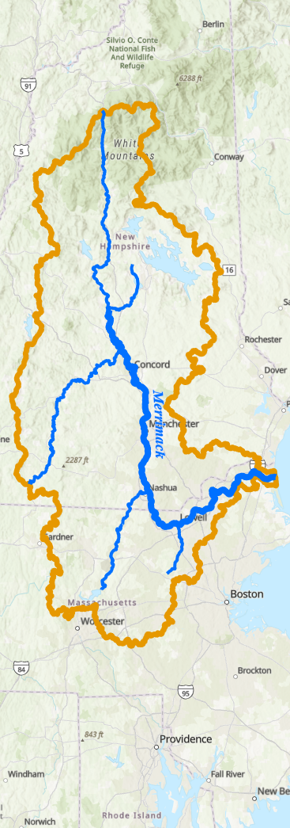

|  |  |  |
| --- | --- | --- |
| Introduction |  | |
| Wastewater management and treatment is an ever-growing challenge in modern society, often exacerbated by outdated technology and policies long overdue for updating. New England has experienced increasingly wet weather over the past several years with the local impact of changing global climates leading to an increase in annual average precipitation as well as an increase in single event rainfall. Increased rainfall events have caused problems for many urban regions of Massachusetts due to increasing urbanization and usage of non-permeable construction materials and the challenge of updating municipal combined sewer systems. These three factors all contributed to making 2023 a record year for sewage pollution in the Merrimack River watershed and deserve closer inspection.[1]  Combined Sewer Outfalls  This investigation was focused on building an understanding of local combined sewer outfalls. According to the United Stated Environmental Protection Agency (EPA)[2] a Combined Sewer is a “system [that] collects rainwater runoff, domestic sewage, and industrial wastewater into one pipe”. An outfall or overflow pipe is used to discharge overflow from this system if the runoff exceeds the capacity of the system. Because these combined sewer outfalls (referred to hereafter as CSOs) discharge raw sewage with high levels of contaminants, they are subject to permitting requirements and enforcement by the EPA and other local regulatory bodies. A map of a city  Description automatically generated  Figure 1: Lowell Municipal CSOs along the Merrimack River  Merrimack River Watershed  The Merrimack River originates in central New Hampshire, but the regional watershed for the river system extends to cover a significant portion of Northeastern Massachusetts following the river’s outflow to the Atlantic. This means that regionally, all drainage contributes to feeding the Merrimack whether it is through a tributary or simple groundwater movement. The watershed is further divided into smaller and smaller portions to recognize the disparate elevation changes and smaller pooling regions. These local level watershed boundaries are the most deeply influenced by growing urbanization and will be discussed later. Using these boundaries to investigate the lower portion of the greater Merrimack River watershed allows us to get a better understanding of the regional impact of the increase in urbanization.    Figure 2: Lower Merrimack River Watershed with Combined Sewer Outfalls and Wastewater Treatment Plants | |  |

|  |  |  |
| --- | --- | --- |
| Method |  | |
| The focus of this investigation was to determine a correlation between increasing urbanization and CSO discharges affecting the health of the Merrimack River. Initially beginning with an investigation of the entirety of the Merrimack River watershed, for efficacy and impact the area of study was limited to the lower Merrimack River region constituting the portion of the river within Massachusetts itself. Additionally, the focus at times narrows to the city of Lowell as a region indicative of the problem at hand. This report was constructed using ArcGIS Pro to develop regional maps as well as datasets compiled from government sources for Massachusetts and New Hampshire.  Data Gathering  Necessary data for this investigation was pulled from MassGIS and the EPA. Data from the EPA’s set focusing on the Merrimack River watershed was particularly useful and had previously been compiled as part of a story map for the Watershed. Additional data from MassGIS was used to determine changes in zoned land usage over the past 50 years. By using datasets compiled by these agencies, significant savings were made in time and resources to allow for a specialized historical investigation of the region. All relevant datasets will be linked in the appendices of this report.  Data Manipulation and Visualization  The core of the report was achieved through the following process through the use of ArcGIS Pro to create spatial relationships and visualize the resulting information in a meaningful capacity. Following explanations of the methodology involved, a few relevant layouts will be presented with commentary.  Following gathering of the initial data the first task was to complete an analysis of the change in historical land usage. This was achieved by using Land Use/Land Cover datasets compiled by MassGIS from 1971 to 2016. With 45 years of data to compare, the hope was to discover differentiation in the level of urbanization and impervious material usage in the Lower Merrimack Watershed. This was achieved by first taking the Land Use (1951-1999) dataset compiled by the Massachusetts Bureau of Geographic Information (MassGIS) and manipulating to extract the data of interest. According to MassGIS this dataset is polygonal data with 37 classifications compiled from 1:25,000 aerial photography.[3] While the set contains data from as far back as 1951, this mapping was done for only Cape Cod and is thus not relevant. Statewide mapping includes data from 1971, 1983, and 1999. For our purposes we were interested in only the data from 1971 as there is updated data from 2016[4] for comparison. Additionally at this step data for the greater Merrimack Watershed was used to denote boundaries for the study. This data was gathered from the Merrimack River Watershed Extent dataset[5] compiled by the EPA and accessible through the ArcGIS hub. Using the Hydrological Unit Code (HUC) 6 boundaries denoting basin level boundaries, the state border of Massachusetts was used to portion the lower Merrimack River. This was done due to misalignment in the date ranges for available land use between Massachusetts and New Hampshire. By focusing on the lower Merrimack as a separate portion from the upper region, no temporal adjustments needed to be done to relate the data.  Once the HUC6 boundary was portioned off at the border, it became the de facto boundary for the statewide land use datasets. All further sets were clipped using this boundary to focus on the area of interest. Further investigation of the datasets revealed a discontinuity issue between the 1971 data and the 2016 data. Using aerial photography in the 1971 dataset allowed MassGIS to compile polygonal approximations of land parcels and assign use codes while the 2016 dataset used updated techniques and technology combined with aerial photography to produce maps accurate to within a meter of the actual use. This means that rather than a whole lot of a single family residence being considered “impervious”, a house and the gardens/lawns surrounding the house would have separate classifications allowing for much higher levels of accuracy. Additionally, the 2016 data contains 19 classes for Land Cover as well as 16 classes for Land Use. These two classifications are differentiated by the National Oceanic and Atmospheric Administration (NOAA) as follows: “Land cover indicates the physical land type such as forest or open water whereas land use documents how people are using the land.”[6] For our purposes, the Land Cover classification was more useful as it contains the classification “Impervious” meaning that whatever materials cover the land (housing, roads, etc) is not permeable by water and thus transforms free water into runoff. Greater concentrations of impervious land create more flow to the river and thus create higher load on the combined sewage systems of larger municipalities.  While the 2016 data contains the “Impervious” classification, the 1971 dataset is exclusively Land Use and had to be manipulated in order to compare appropriately to the 2016 dataset. A new layer was created by attribute selection to include the following classifications as impervious land cover: Residential (including single and multifamily), Commercial, Industrial, and Transportation. All other classifications were various types of permeable land. Another new layer was created from the 2016 data including only polygons in the “Impervious” classification. Following this, the 1971 data required further adjustment due to earlier discussion of the lower degree of polygonal accuracy. Initially a spatial join was attempted, but ArcGIS was unable to calculate large aggregate information due to a complication of joining the disparate datasets. As the largest changes were in the “Single-family residential” classification, the greatest bloat in land area occurred from the inclusion of lawn space in residential lots. To accommodate for this change, the 1971 data was clipped using the 2016 data as a classifier to produce new polygons representing just the impervious surfaces of those lots. While this does lead to potential error in the form of eliminating buildings that have been torn down and not rebuilt, it was thought that the increase in impervious building would far outpace any reduction. With 50-year changes on the order of hundreds of millions of square feet, it is unlikely this error would significantly affect resulting observations.    Following the clipping of the 1971 data, the next step was to compare them and generate a heatmap of the areas of greatest change. A new layer was created by selecting all polygons in the 2016 set with the classification “Impervious” that did not have a correlating polygon in the clipped 1971 data. This layer was then converted from polygons to points and a kernel-density map was generated. This allowed visualization and analysis of the greatest change in impervious land development over a 45-year period. These steps were then repeated using only the 2016 data to generate a similar kernel-density map of the concentration of impervious land cover for the boundaries. Using these two density maps allows for analysis of the land cover.  Returning to the Merrimack River Watershed Extent dataset, the final map of interest was created by simply examining an area of high-density impervious land cover which also contained a combined sewer system. Lowell was selected for this analysis as it is directly on the Merrimack and contains 8 CSOs which discharge directly into the Merrimack. Additionally, the Lowell water treatment plant has the second highest processing capacity in the region making it a compelling candidate for analysis.  Further analysis of the region of interest zoomed in to the Merrimack river and was focused on comparison of the relative land cover in the immediate vicinity of the river bank. By utilizing the Merrimack River Watershed layer to gather geocoded data regarding the river itself, a one mile buffer zone was created surrounding the Merrimack river and major tributaries. This buffer was used to clip the land use and land cover data from 1971 and 2016 to restrict the area of focus to within this boundary of the river. Further refinement was made to restrict the region of inspection to within those communities along the riverbank that rely on combine sewer systems. By using the clipped 1971 data discussed earlier, the table of data was modified to calculate the percentage of land cover within this area made up of impervious surfaces to compare the growth of problematic land coverage within the 45-year period. This provided a close look at the regions of land most responsible for the increased influx of stormwater directly influencing sewage discharges into the Merrimack.  A map of a city  Description automatically generatedFollowing the engineering of the visual data further analysis of the numerical data was completed to understand what these visualizations represent. A spatial join between the 1971 and 2016 layers allowed isolation of fresh development. Joining the resulting table of data to the Merrimack land buffer zone area brought all the relevant data into one place for comparative analysis.  Processing this data required first that all area data be converted into the same units. All area data was converted from a variety of input metrics into square footage and then compared to the overall area of the buffer region. Values were once again restricted to regions relying on combine sewer systems to focus on areas of greatest impact of the impervious surface coverage. Finally, summary statistics of the relevant areas were calculated and analyzed, discussed below. | |  |

|  |  |  |  |  |
| --- | --- | --- | --- | --- |
| Results & Discussion | | |  | |
| While the primary focus of this report is CSOs using Lowell’s system as an example for discussion, the analysis of changing land coverage yielded some interesting results as well. The largest capacity water treatment plant in the region is the Greater Lawrence Sanitary District which serves the North Andover region with a maximum daily processing capacity of 52 million gallons per day (MGD) and processes a daily average of 30 MGD. This allows for a 73% buffer of daily processing capacity in the event of wet weather. Lowell Regional Waterworks Utility came in at number 2 with a max capacity of 31 MGD and a daily average of 26 MGD, or a 19% buffer. These are by far the largest plants in the region with only two other facilities capable of processing over 10 MGD (Haverhill and Fitchburg). | | | |  |
| According to the Merrimack River Watershed Council (MRWC)[7], 2023 was a drastic increase in discharge of raw sewage into the Merrimack River. The previous highest total on record was 2021 with 823 million gallons of CSO discharge while 2023 totaled at over 2 billion gallons, a 143% increase. The two largest discharge amounts in the watershed were Manchester, NH with 875 million gallons and Lowell with 850 million gallons. Greater Lawrence meanwhile had a yearly total of 164 million gallons. This means that due to significant increases in annual rainfall for 2023, two single CSOs along the Merrimack had discharge totals above the previous yearly record total for the entire river. |  | “The enormous amount of rain we received last year was the primary reason why we had such an astonishingly high volume of CSO waste discharged into the river…I heard many complaints [..] about the unhealthy appearance of the river last year.”[8] | |  |
| Additionally, the largest plant in our area of interest (Greater Lawrence) had a drastically lower rate of discharge than the Lowell plant which can be accounted for by its maximum capacity being 73% above its average daily volume while the Lowell plant sits at a 19% buffer. This became a problem for Lowell in both 2021 and 2023 with rainfall in 2021 totaling 52.96 inches[9] and 2023 rainfall totaling 61.52 inches[10]. Significantly higher rainfall than the average annual amount of 47 inches[11] produced stress on the systems and caused these shocking rates of discharge from the Lowell plant.  What does this mean when combined with our historical land coverage data? Looking at the maps for urbanization rate and impervious surface concentration we see a deep overlap of hot spots in and surrounding the greater Lowell area. Lowell itself has one of the 3 highest concentrations of impervious surfaces in the region, comparable to only Lawrence and Haverhill. All 3 of these hotspots lie directly on the Merrimack itself, meaning that their CSOs discharge directly into the river body. Additionally looking at the urbanization map over 45 years reveals that outside of the northeastern edge of Worcester (the only part of the metropolitan area within our watershed boundary), Lowell maintains the highest rate of urbanization in the region extending down towards Littleton along I-495. This indicates that Lowell has experienced the most rapid urbanization of the region over the past half century and maintains a significantly higher concentration of impervious surface area than any other region within the lower Merrimack watershed. Finally, the impervious surface area within the entire lower portion of the watershed has more than doubled since 1971 with an increase from roughly 150 million square feet to a staggering ~360 million square feet of impervious surfaces.  Expanding the focus slightly from centering on Lowell, the remainder of the analysis is related to communities with combined sewer systems at large within the lower Merrimack. By taking the data engineered regarding the relative expansion of impervious surface coverage, we can see the stark contrast of the above change in impervious surface area reflected even more drastically in the areas of interest. Among communities with combined sewers, total impervious coverage in the river buffer zone has risen from just under 5% to nearly 17% over the previous 45-year period. This 248% increase in impervious surface coverage in the region directly impacts the amount of stormwater which needs to be processed by the combined sewage system and results in the startling numbers we see regarding continued increase of sewage discharge into the river. Data regarding direct effects on water quality is difficult to make use of as prior to the mid-1960s untreated sewage appears to A graph of a number of different types of coverage  Description automatically generated with medium confidencehave been liberally discharged and many environmental protection requirements were not implemented until after the beginning of this study. However, the fact that we have seen record high levels of discharge and ever increasing volumes in recent years is even more concerning given that context: discharge levels are continuing to outpace attempts to regulate them and leave the Merrimack River one of America’s most polluted rivers and municipal water sources.  While this discussion has primarily focused on breaking down the CSO discharge events in Lowell and examining why there has been such a significant increase to reach the record totals of 2023, the dramatic increase in use of impervious construction materials throughout the region and its effect on drainage cannot be ignored. Combining the geography of the region naturally encouraging runoff to drain toward the Merrimack from all directions and the decrease in the region’s ability to properly handle rainfall runoff creates a situation where the combined sewer systems employed by municipalities experience more frequent outfall discharges at higher capacities. | | | |  |

|  |  |  |
| --- | --- | --- |
| Conclusions & Policy Recommendations |  | |
| Throughout the course of this report the details of non-permeable materials and increasingly wet climates have clearly been linked to a dramatic rise in sewage discharges into the Merrimack River. Given that a significant portion of northeastern Massachusetts directly draws drinking water from the river, these massive outfalls require a sharp increase in necessary resources for water treatment for consumption and usage. Thus, the following policy recommendations from the EPA and state agencies should be considered for action to alleviate this crisis:   1. Green/Gray Infrastructure: The Clean Water Act (CWA) defines this as “the range of measures that use plant or soil systems, permeable pavement, or other permeable surfaces or substrates, stormwater harvest and reuse, or landscaping to store, infiltrate, or evapotranspirate stormwater and reduce flows to sewer systems or to surface waters.” By prioritizing increased green space and use of permeable materials in urban areas, cities can reduce the amount of rainfall that interacts with the sewer system and reduce load. 2. Integrated Planning: A holistic, long-term way to help communities achieve multiple CWA requirements. Integrated planning focuses on efficient ways to separate stormwater and wastewater to manage both capital investments and health and environmental targets. 3. Reduction of CSOs: With many of the states sewer systems dating back over a century, retrofitting and redesigning active systems is a costly endeavor and requires careful planning as they are always in use. Expanding station capacity and additional pipe infrastructure can help improve peak processing capacity and help reduce outfall discharge necessity. 4. Sewer Separation: Given that CSOs are an outdated sewage management system existing in this region largely due to the historical era they were constructed in, the ideal solution would be to retrofit or completely redesign the systems to meet modern standards. By separating storm sewers from wastewater sewers, the problem of discharges can be significantly minimized as stormwater requires much less significant treatment than wastewater.   By focusing capital investments and resources on implementing these policy adjustments, we can provide a substantial improvement to not only the health of our waterways but also minimize the long-term economic impact and requirements to manage these municipal systems. Limitations & Next Steps A brief discussion regarding the limitations of this study is warranted, as well as a focus on the next steps to be taken in analysis. First and foremost, this is a surface level analysis of many of the issues facing the Merrimack River and urban pollution generally. This study was undertaken primarily as an exercise in engaging with ArcGIS Pro and not as a full-fledged research effort to obtain novel information or understanding. The goal of this project was to build familiarity and show an understanding of diverse tools and analytical processes within the software.  Given the above scope, the limitations of this study become quickly apparent. While I engaged in significant discussion of weather-related pressures on these CSO systems, little weather-related data was gathered and used. A significant area of improvement for this study would be to compare precipitation levels over the indicated timespan and attempt to find separation between levels of increasing precipitation and increasing impervious coverage. Analysis of a large set of temporal precipitation data would allow for investigation of patterns to see if wet weather is a primary consistent causal variable in the increase of CSO discharges. Most compelling would be to find a disparity in the rise of annual precipitation with the rise of discharge events.  Additionally, a study would be warranted to specifically compare the Lowell and Lawrence regions as these regions are geographically nearby and would be expected to receive similar levels of precipitation and runoff. Looking at the differences between how these municipalities approach the water treatment systems and sewer reliance would provide critical insights in how best to mitigate these events in the Lowell region and other similar regions.  One future direction for this study would be to build an analysis of the direct effects of impervious coverage on CSO influx and comparing flow rates and management capacities of the treatment systems related to these CSO systems. The above analysis largely investigates surface coverage and assumes a link between impervious surface material usage and rising discharge rates into the river body. Geospatial datasets from these regions could be implemented at a micro-level to investigate first the direct change in wastewater flow and management to understand how the specific materials and distribution of impervious coverage impacts the flow of stormwater and wastewater. These analyses could then be extrapolated out to the larger region. Completing a more cohesive analysis of the region would lead to more direct and specific policy interventions as well as actionable recommendations for the municipalities involved. Appendix | |  |

Bibliography

EPA. “Combined Sewer Overflows (CSOs).” National Pollutant Discharge Elimination System (NPDES). Accessed August 7, 2024. https://www.epa.gov/npdes/combined-sewer-overflows-csos.

EPA. “Merrimack River Watershed Extent.” ArcGIS Hub. Accessed August 7, 2024. https://hub.arcgis.com/maps/200c5c29d98e41998e6a9f83e804dde6/about.

Lowell, City of. “Combined Sewer Overflows (CSO).” Combined Sewer Overflows (CSO) | Lowell, MA. Accessed August 7, 2024. https://www.lowellma.gov/1287/Combined-Sewer-Overflows-CSO.

Macone, John. “2023: A Record-Setting Year for Sewer Discharges.” Merrimack River Watershed Council, January 30, 2024. https://merrimack.org/2024/01/30/2023-a-record-setting-year-for-sewer-discharges/.

MassGIS. “Massgis Data: 2016 Land Cover/Land Use.” Mass.gov. Accessed August 7, 2024. https://www.mass.gov/info-details/massgis-data-2016-land-coverland-use.

MassGIS. “Massgis Data: Land Use (1951-1999).” Mass.gov. Accessed August 7, 2024. https://www.mass.gov/info-details/massgis-data-land-use-1951-1999.

NOAA. “Climate.” National Weather Service, July 30, 2024. https://www.weather.gov/wrh/Climate?wfo=box.

NOAA. “Weather Averages Lowell, Massachusetts.” US Climate Data. Accessed August 7, 2024. https://www.usclimatedata.com/climate/lowell/massachusetts/united-states/usma0223.

NOAA. “What Is the Difference between Land Cover and Land Use?” NOAA’s National Ocean Service, September 10, 2009. <https://oceanservice.noaa.gov/facts/lclu.html#:~:text=Land%20cover%20indicates%20the%20physical,land%20use%20trends%20and%20changes>.

Summary of Graphical and Analytical Tools

This list comprises a summary of ArcGIS tools and processes used to create the above report and graphics

* Clip and Pairwise Clip
* Spatial Join and Tabular Join; Tabular relate
* Tabular calculation and graphical organization
* Pairwise Intersection and Dissolution
* Buffering
* Manipulation of Image and Raster data
* Alignment of temporal datasets on feature similarity
* Polygon-to-point conversion and kernel density analysis
* Area scaling and unit conversion
* Spatial projection and alignment of various projection sets

Relevant Informational Graphics and Layouts

1. John Macone, “2023: A Record-Setting Year for Sewer Discharges”, Merrimack River Watershed Council:, January 20, 2024, https://merrimack.org/2024/01/30/2023-a-record-setting-year-for-sewer-discharges/.
2. EPA, “Combined Sewer Overflows (CSOs)”, October 5, 2023, https://www.epa.gov/npdes/combined-sewer-overflows-csos.
3. MassGIS, “MassGIS Data: Land Use (1951-1999)”, Massachusetts Bureau of Geographical Information, January 1, 2002, https://www.mass.gov/info-details/massgis-data-land-use-1951-1999.
4. MassGIS, “MassGIS Data: 2016 Land Cover/Land Use”, May, 2019, https://www.mass.gov/info-details/massgis-data-2016-land-coverland-use.
5. EPA, “Merrimack River Watershed Extent”, December 13, 2018, updated April 9, 2024, https://hub.arcgis.com/maps/200c5c29d98e41998e6a9f83e804dde6/about.
6. NOAA, “What is the difference between land cover and land use?”, NOAA, June 16, 2024, https://oceanservice.noaa.gov/facts/lclu.html#:~:text=Land%20cover%20indicates%20the%20physical,land%20use%20trends%20and%20changes.
7. Macone, “2023: A Record-Setting Year for Sewer Discharges”
8. Ibid.
9. City of Lowell, “2021 High-Flow Management Operations and Performance Report”, Lowell Wastewater Utility, <https://www.lowellma.gov/1287/Combined-Sewer-Overflows-CSO>.
10. NOAA, “Climate for Lowell, MA, 2023”, https://www.weather.gov/wrh/Climate?wfo=box.
11. US Climate Data, “Lowell Weather Averages”, Station averages published in 2019, https://www.usclimatedata.com/climate/lowell/massachusetts/united-states/usma0223.